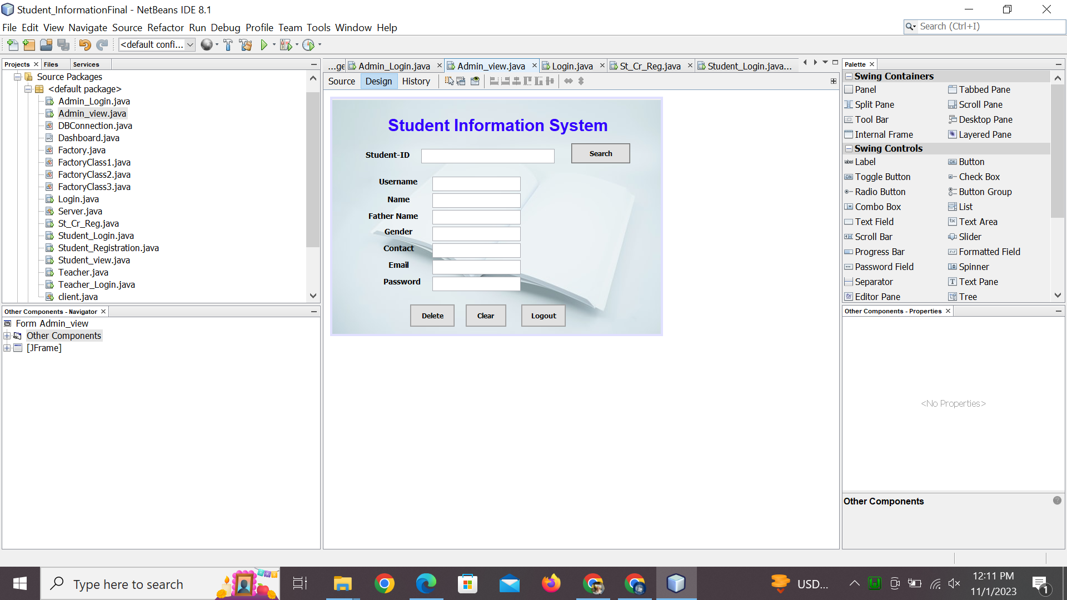

import java.sql.Connection;

import java.sql.PreparedStatement;

import java.sql.ResultSet;

import java.sql.Statement;

import javax.swing.JOptionPane;

/*

* To change this license header, choose License Headers in Project Properties.

* To change this template file, choose Tools | Templates

* and open the template in the editor.

*/

/**

*

* @author Chaudhry Hammad

*/

public class Admin_view extends javax.swing.JFrame {

Connection con=DBConnection.getDBConnection();

/**

* Creates new form Admin_view

*/

public Admin_view() {

initComponents();

}

/**

* This method is called from within the constructor to initialize the form.

* WARNING: Do NOT modify this code. The content of this method is always

* regenerated by the Form Editor.

*/

@SuppressWarnings("unchecked")

// <editor-fold defaultstate="collapsed" desc="Generated Code">

private void initComponents() {

jLabel1 = new javax.swing.JLabel();

jLabel3 = new javax.swing.JLabel();

stid = new javax.swing.JTextField();

searchbtn = new javax.swing.JButton();

jLabel4 = new javax.swing.JLabel();

jLabel5 = new javax.swing.JLabel();

jLabel7 = new javax.swing.JLabel();

fname = new javax.swing.JTextField();

gender = new javax.swing.JTextField();

name = new javax.swing.JTextField();

jLabel8 = new javax.swing.JLabel();

contact = new javax.swing.JTextField();

jLabel9 = new javax.swing.JLabel();

email = new javax.swing.JTextField();

deletebtn = new javax.swing.JButton();

Clearbtn = new javax.swing.JButton();

jLabel2 = new javax.swing.JLabel();

password = new javax.swing.JTextField();

jLabel10 = new javax.swing.JLabel();

username = new javax.swing.JTextField();

logoutbtn = new javax.swing.JButton();

jLabel13 = new javax.swing.JLabel();

setDefaultCloseOperation(javax.swing.WindowConstants.EXIT_ON_CLOSE);

getContentPane().setLayout(new org.netbeans.lib.awtextra.AbsoluteLayout());

jLabel1.setFont(new java.awt.Font("Arial", 1, 30)); // NOI18N

jLabel1.setForeground(new java.awt.Color(51, 0, 255));

jLabel1.setHorizontalAlignment(javax.swing.SwingConstants.CENTER);

jLabel1.setText("Student Information System");

jLabel1.setCursor(new java.awt.Cursor(java.awt.Cursor.DEFAULT_CURSOR));

getContentPane().add(jLabel1, new org.netbeans.lib.awtextra.AbsoluteConstraints(100, 30, -1, -1));

jLabel3.setFont(new java.awt.Font("Tahoma", 1, 14)); // NOI18N

jLabel3.setHorizontalAlignment(javax.swing.SwingConstants.CENTER);

jLabel3.setText("Student-ID");

getContentPane().add(jLabel3, new org.netbeans.lib.awtextra.AbsoluteConstraints(50, 90, 98, 20));

stid.addKeyListener(new java.awt.event.KeyAdapter() {

public void keyTyped(java.awt.event.KeyEvent evt) {

stidKeyTyped(evt);

}

});

getContentPane().add(stid, new org.netbeans.lib.awtextra.AbsoluteConstraints(160, 90, 240, -1));

searchbtn.setBackground(new java.awt.Color(102, 102, 102));

searchbtn.setFont(new java.awt.Font("Tahoma", 1, 12)); // NOI18N

searchbtn.setText("Search");

searchbtn.setBorder(null);

searchbtn.addActionListener(new java.awt.event.ActionListener() {

public void actionPerformed(java.awt.event.ActionEvent evt) {

searchbtnActionPerformed(evt);

}

});

getContentPane().add(searchbtn, new org.netbeans.lib.awtextra.AbsoluteConstraints(430, 80, 106, 36));

jLabel4.setFont(new java.awt.Font("Tahoma", 1, 14)); // NOI18N

jLabel4.setHorizontalAlignment(javax.swing.SwingConstants.CENTER);

jLabel4.setText("Father Name");

getContentPane().add(jLabel4, new org.netbeans.lib.awtextra.AbsoluteConstraints(60, 200, 98, 20));

jLabel5.setFont(new java.awt.Font("Tahoma", 1, 14)); // NOI18N

jLabel5.setHorizontalAlignment(javax.swing.SwingConstants.CENTER);

jLabel5.setText("Name");

getContentPane().add(jLabel5, new org.netbeans.lib.awtextra.AbsoluteConstraints(70, 170, 98, 20));

jLabel7.setFont(new java.awt.Font("Tahoma", 1, 14)); // NOI18N

jLabel7.setHorizontalAlignment(javax.swing.SwingConstants.CENTER);

jLabel7.setText("Gender");

getContentPane().add(jLabel7, new org.netbeans.lib.awtextra.AbsoluteConstraints(70, 230, 98, -1));

getContentPane().add(fname, new org.netbeans.lib.awtextra.AbsoluteConstraints(180, 230, 159, -1));

gender.addActionListener(new java.awt.event.ActionListener() {

public void actionPerformed(java.awt.event.ActionEvent evt) {

genderActionPerformed(evt);

}

});

getContentPane().add(gender, new org.netbeans.lib.awtextra.AbsoluteConstraints(180, 260, 159, -1));

getContentPane().add(name, new org.netbeans.lib.awtextra.AbsoluteConstraints(180, 200, 159, -1));

jLabel8.setFont(new java.awt.Font("Tahoma", 1, 14)); // NOI18N

jLabel8.setHorizontalAlignment(javax.swing.SwingConstants.CENTER);

jLabel8.setText("Contact");

getContentPane().add(jLabel8, new org.netbeans.lib.awtextra.AbsoluteConstraints(70, 260, 98, -1));

contact.addActionListener(new java.awt.event.ActionListener() {

public void actionPerformed(java.awt.event.ActionEvent evt) {

contactActionPerformed(evt);

}

});

getContentPane().add(contact, new org.netbeans.lib.awtextra.AbsoluteConstraints(180, 290, 159, -1));

jLabel9.setFont(new java.awt.Font("Tahoma", 1, 14)); // NOI18N

jLabel9.setHorizontalAlignment(javax.swing.SwingConstants.CENTER);

jLabel9.setText("Email");

getContentPane().add(jLabel9, new org.netbeans.lib.awtextra.AbsoluteConstraints(70, 290, 98, -1));

email.addActionListener(new java.awt.event.ActionListener() {

public void actionPerformed(java.awt.event.ActionEvent evt) {

emailActionPerformed(evt);

}

});

getContentPane().add(email, new org.netbeans.lib.awtextra.AbsoluteConstraints(180, 320, 159, -1));

deletebtn.setBackground(new java.awt.Color(153, 153, 153));

deletebtn.setFont(new java.awt.Font("Tahoma", 1, 12)); // NOI18N

deletebtn.setText("Delete");

deletebtn.setBorder(null);

deletebtn.addActionListener(new java.awt.event.ActionListener() {

public void actionPerformed(java.awt.event.ActionEvent evt) {

deletebtnActionPerformed(evt);

}

});

getContentPane().add(deletebtn, new org.netbeans.lib.awtextra.AbsoluteConstraints(140, 370, 80, 40));

Clearbtn.setBackground(new java.awt.Color(153, 153, 153));

Clearbtn.setFont(new java.awt.Font("Tahoma", 1, 12)); // NOI18N

Clearbtn.setText("Clear");

Clearbtn.setBorder(null);

Clearbtn.addActionListener(new java.awt.event.ActionListener() {

public void actionPerformed(java.awt.event.ActionEvent evt) {

ClearbtnActionPerformed(evt);

}

});

getContentPane().add(Clearbtn, new org.netbeans.lib.awtextra.AbsoluteConstraints(240, 370, 73, 40));

jLabel2.setFont(new java.awt.Font("Tahoma", 1, 14)); // NOI18N

jLabel2.setText(" Password");

getContentPane().add(jLabel2, new org.netbeans.lib.awtextra.AbsoluteConstraints(80, 320, 98, -1));

getContentPane().add(password, new org.netbeans.lib.awtextra.AbsoluteConstraints(180, 140, 159, -1));

jLabel10.setFont(new java.awt.Font("Tahoma", 1, 14)); // NOI18N

jLabel10.setText(" Username");

getContentPane().add(jLabel10, new org.netbeans.lib.awtextra.AbsoluteConstraints(80, 140, 87, -1));

getContentPane().add(username, new org.netbeans.lib.awtextra.AbsoluteConstraints(180, 170, 159, -1));

logoutbtn.setBackground(new java.awt.Color(153, 153, 153));

logoutbtn.setFont(new java.awt.Font("Tahoma", 1, 12)); // NOI18N

logoutbtn.setText("Logout");

logoutbtn.setBorder(null);

logoutbtn.addActionListener(new java.awt.event.ActionListener() {

public void actionPerformed(java.awt.event.ActionEvent evt) {

logoutbtnActionPerformed(evt);

}

});

getContentPane().add(logoutbtn, new org.netbeans.lib.awtextra.AbsoluteConstraints(340, 370, 80, 40));

jLabel13.setIcon(new javax.swing.ImageIcon(getClass().getResource("/ICONS/back11.jpg"))); // NOI18N

jLabel13.setText("jLabel13");

getContentPane().add(jLabel13, new org.netbeans.lib.awtextra.AbsoluteConstraints(0, 0, 600, 430));

pack();

}// </editor-fold>

private void contactActionPerformed(java.awt.event.ActionEvent evt) {

// TODO add your handling code here:

}

private void emailActionPerformed(java.awt.event.ActionEvent evt) {

// TODO add your handling code here:

}

private void ClearbtnActionPerformed(java.awt.event.ActionEvent evt) {

// TODO add your handling code here:

stid.setText("");

username.setText("");

name.setText("");

fname.setText("");

gender.setText("");

contact.setText("");

email.setText("");

password.setText("");

}

private void genderActionPerformed(java.awt.event.ActionEvent evt) {

// TODO add your handling code here:

}

private void searchbtnActionPerformed(java.awt.event.ActionEvent evt) {

// TODO add your handling code here:

searchStudent();

}

public boolean searchStudent(){

try{

String id=stid.getText();

Statement stm= con.createStatement();

String sql="select * from student where id='"+id+"'";

ResultSet rs= stm.executeQuery(sql);

if(rs.next()==false){

JOptionPane.showMessageDialog(this,"Record not found");

name.setText("");

fname.setText("");

gender.setText("");

contact.setText("");

email.setText("");

}

else{

username.setText(rs.getString("username"));

name.setText(rs.getString("name"));

fname.setText(rs.getString("fathername"));

gender.setText(rs.getString("gender"));

contact.setText(rs.getString("contact"));

email.setText(rs.getString("email"));

password.setText(rs.getString("password"));

}

return true;

}

//

catch(Exception e){

System.out.println(e);

return false;

}

}

private void stidKeyTyped(java.awt.event.KeyEvent evt) {

// TODO add your handling code here:

char c=evt.getKeyChar();

if(Character.isLetter(c))

{

stid.setEditable(false);

JOptionPane.showMessageDialog(this,"Enter number only");

}

else{

stid.setEditable(true);

}

}

private void deletebtnActionPerformed(java.awt.event.ActionEvent evt) {

// TODO add your handling code here:

try{

String sql1="delete from student where id=?";

PreparedStatement pstmt=con.prepareStatement(sql1);

pstmt.setInt(1,Integer.parseInt(stid.getText()));

pstmt.executeUpdate();

JOptionPane.showMessageDialog(null,"Record deleted successfully");

con.close();

}

catch(Exception e){

JOptionPane.showMessageDialog(null,e);

}

}

private void logoutbtnActionPerformed(java.awt.event.ActionEvent evt) {

// TODO add your handling code here:

Login login=new Login();

login.setVisible(true);

dispose();

}

/**

* @param args the command line arguments

*/

public static void main(String args[]) {

/* Set the Nimbus look and feel */

//<editor-fold defaultstate="collapsed" desc=" Look and feel setting code (optional) ">

/* If Nimbus (introduced in Java SE 6) is not available, stay with the default look and feel.

* For details see http://download.oracle.com/javase/tutorial/uiswing/lookandfeel/plaf.html

*/

try {

for (javax.swing.UIManager.LookAndFeelInfo info : javax.swing.UIManager.getInstalledLookAndFeels()) {

if ("Nimbus".equals(info.getName())) {

javax.swing.UIManager.setLookAndFeel(info.getClassName());

break;

}

}

} catch (ClassNotFoundException ex) {

java.util.logging.Logger.getLogger(Admin_view.class.getName()).log(java.util.logging.Level.SEVERE, null, ex);

} catch (InstantiationException ex) {

java.util.logging.Logger.getLogger(Admin_view.class.getName()).log(java.util.logging.Level.SEVERE, null, ex);

} catch (IllegalAccessException ex) {

java.util.logging.Logger.getLogger(Admin_view.class.getName()).log(java.util.logging.Level.SEVERE, null, ex);

} catch (javax.swing.UnsupportedLookAndFeelException ex) {

java.util.logging.Logger.getLogger(Admin_view.class.getName()).log(java.util.logging.Level.SEVERE, null, ex);

}

//</editor-fold>

/* Create and display the form */

java.awt.EventQueue.invokeLater(new Runnable() {

public void run() {

new Admin_view().setVisible(true);

}

});

}

// Variables declaration - do not modify

private javax.swing.JButton Clearbtn;

private javax.swing.JTextField contact;

private javax.swing.JButton deletebtn;

private javax.swing.JTextField email;

private javax.swing.JTextField fname;

private javax.swing.JTextField gender;

private javax.swing.JLabel jLabel1;

private javax.swing.JLabel jLabel10;

private javax.swing.JLabel jLabel13;

private javax.swing.JLabel jLabel2;

private javax.swing.JLabel jLabel3;

private javax.swing.JLabel jLabel4;

private javax.swing.JLabel jLabel5;

private javax.swing.JLabel jLabel7;

private javax.swing.JLabel jLabel8;

private javax.swing.JLabel jLabel9;

private javax.swing.JButton logoutbtn;

private javax.swing.JTextField name;

private javax.swing.JTextField password;

private javax.swing.JButton searchbtn;

private javax.swing.JTextField stid;

private javax.swing.JTextField username;

// End of variables declaration

}